|  |  |  |  |  |
| --- | --- | --- | --- | --- |
| **Project ID** | **Student Name(s)** | **Registration Number** | **Section (A/B/C)** | **Instructor Remarks** |
| DSVII2024-001 | Mayank V Chopra | 229309229 | C |  |
|  | Kunal Yadav | 229309237 | C |  |

|  |
| --- |
| **Finalized Domain Name:**  **Software** |
| **Finalized Problem Statement:**  **Real-Time Sign Language Translation System**  **To develop a real-time system that converts speech or text into sign language gestures, ensuring**  **seamless communication between non-sign language users and individuals who rely on sign**  **language. The system will integrate deep learning techniques for speech recognition, natural**  **language processing (NLP), and 3D gesture visualization.** |

**Dataset:**

**1. Dataset Link:**

[**https://how2sign.github.io/**](https://how2sign.github.io/)

**2. Summary and screenshot of Dataset**

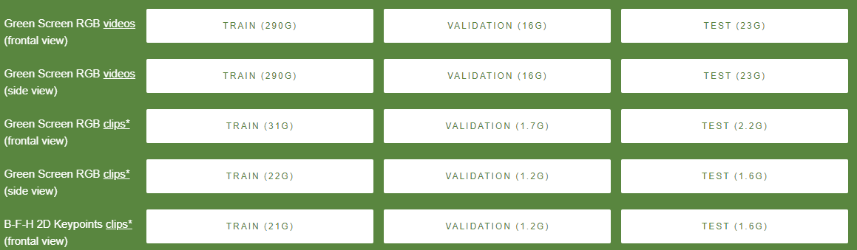

**3. Architecture Diagram/Workflow**

